

**Name: Muhammad Fahad**

**Sap ID: 37125**

**Section: BSCS-4A**

**Course: Web Application Development**

**Assignment#1**

**HTML & HTML5 TAGS**

1. **<address>**

The <address> tag is used to define contact information for the author or owner of a document or article.

**CODE**

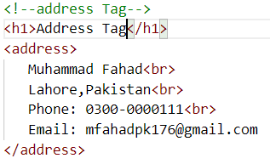

**OUTPUT**

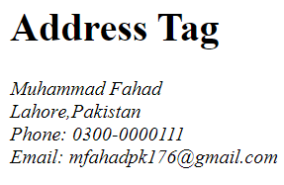

1. **<h1> to <h6>**

Heading tags are used to create headings and subheadings on a web page. There are six different heading tags in HTML, ranging from <h1> for the largest and most important heading, to <h6> for the smallest and least important heading.

**CODE**

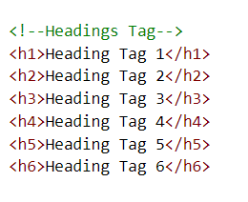

**OUTPUT**

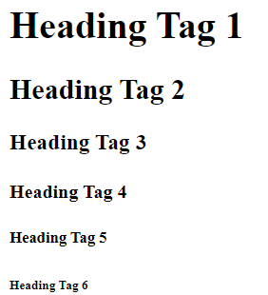

1. **<head>**

Contains meta information about the document, such as the title and links to CSS stylesheets and JavaScript files.

**CODE**

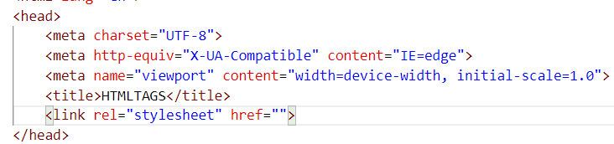

**OUTPUT**

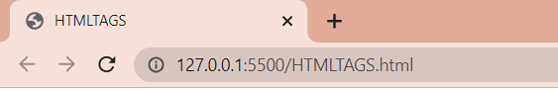

1. **<body>**

Contains the visible content of the document, such as text, images, and other media.

**CODE**

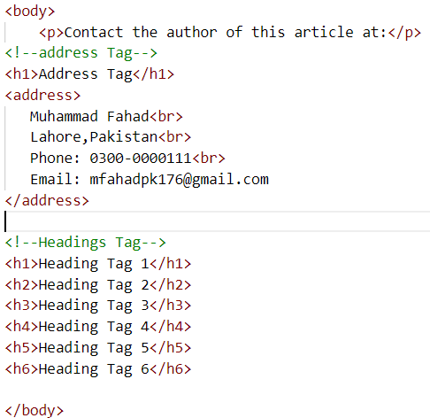

**OUTPUT**

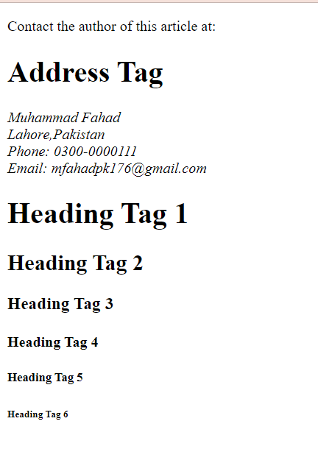

1. **<p>**

Defines a paragraph of text.

**CODE**

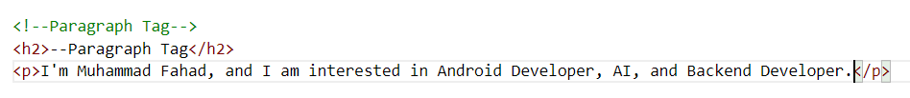

**OUTPUT**

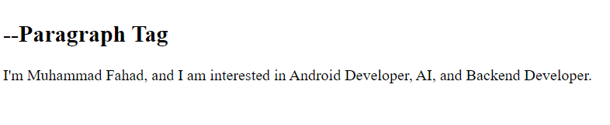

1. **<a>**

Defines a hyperlink to another web page or resource.

**CODE**

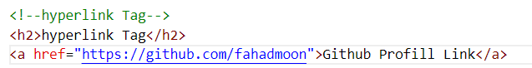

**OUTPUT**

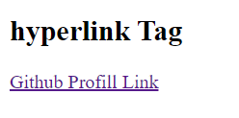

1. **<dialog>**

The <dialog> tag is used to create a dialog box or modal window on a web page.

**CODE**

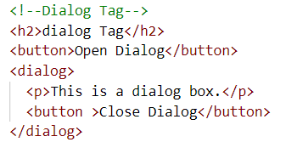

**OUTPUT**

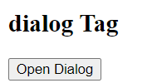

1. **<img>**

Displays an image on the web page.

**CODE**

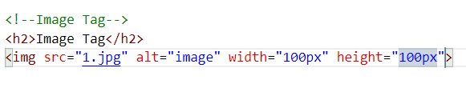

**OUTPUT**



1. **<!DOCTYPE >**

The <!DOCTYPE> declaration is used to specify the type of document being used and its version.

**CODE**

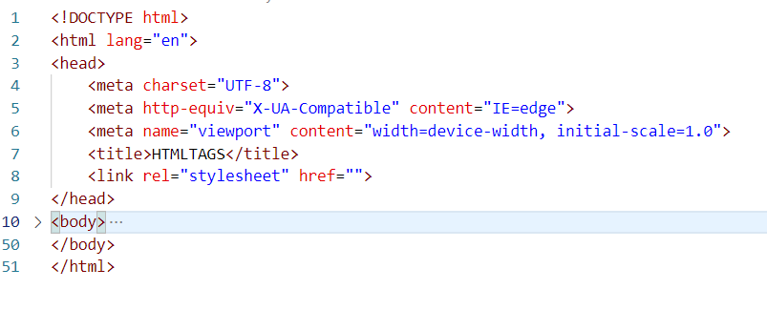

**OUTPUT**

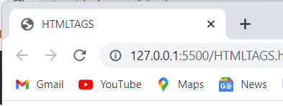

1. **<abbr>**

Use the global title attribute to show the description for the abbreviation when you mouse over the element.

**CODE**



**OUTPUT**

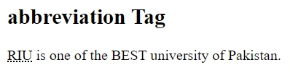

1. **<area>**

The <area> tag defines an area inside an image map (an image map is an image with clickable areas).

**CODE**

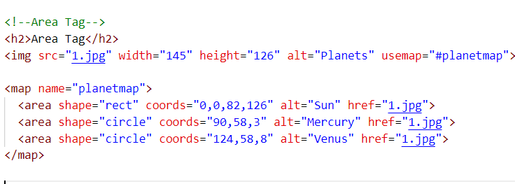

**OUTPUT**

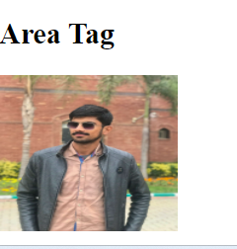

1. **<map>**

The <map> tag is used to define a client-side image map. An image map is an image with clickable areas, or hotspots, that link to different parts of a web page or to external resources.

**CODE**

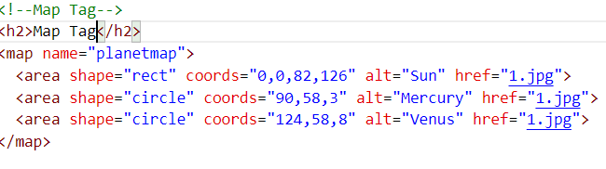

**OUTPUT**

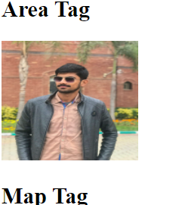

1. **<article>**

This element is used to define an independent piece of content in a document, that may be a blog, a magazine or a newspaper article.

**CODE**

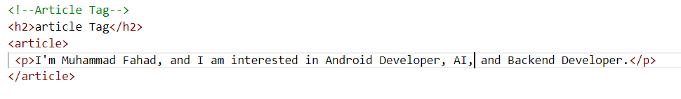

**OUTPUT**

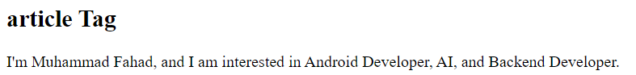

1. **<aside>**

The <aside> tag is used to mark content that is related to the main content of a web page, but not essential to it.

C**ODE**

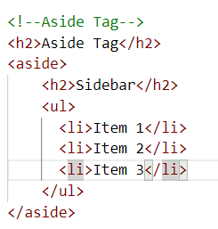

**OUTPUT**

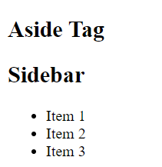

1. **<main>**

The <main> tag is used to define the main content of a web page. It is typically used to contain the primary content of a document, such as the main body of an article or the central content of a web page.

C**ODE**

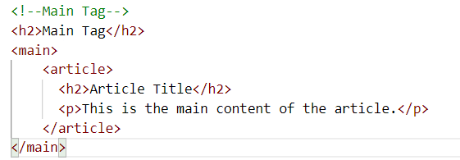

**OUTPUT**

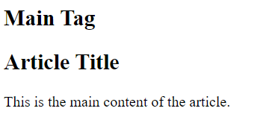

1. **<footer>**

The <footer> tag is used to define the footer section of a web page or a section of the document that appears at the bottom of the content.

C**ODE**

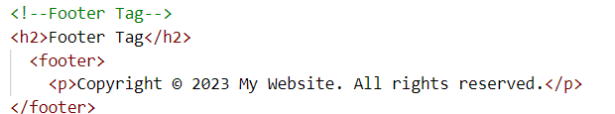

**OUTPUT**

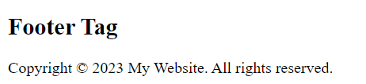

1. **<footer>**

The <footer> tag is used to define the footer section of a web page or a section of the document that appears at the bottom of the content.

C**ODE**



**OUTPUT**



1. **<div>**

The <div> tag is used to create a container for grouping and organizing content. The <div> tag has no semantic meaning of its own, but it is used to group other HTML elements together and apply CSS styles to them.

C**ODE**

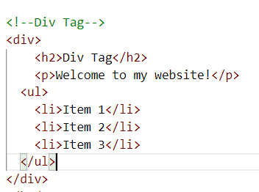

**OUTPUT**

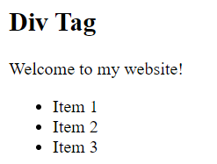

1. **<header>**

<header> tag is used to define the header section of a web page or a section of the document that appears at the top of the content.

C**ODE**

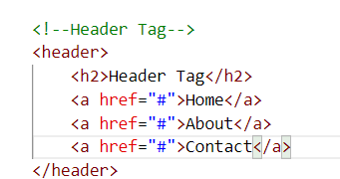

**OUTPUT**

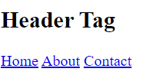

1. **<nav>**

<nav> tag is used to define a section of a web page that contains navigation links. **CODE**

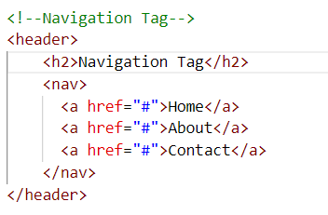

**OUTPUT**

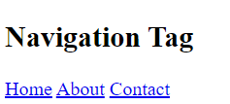

1. **<audio>**

The <audio> tag is used to embed sound content in a document, such as music or other audio streams.

**CODE**

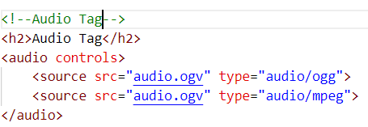

**OUTPUT**

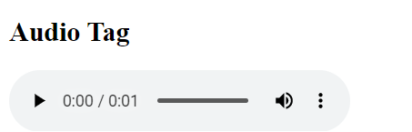

1. **<source>**

The <source> tag is an HTML5 element that is used in conjunction with the <audio> or <video> tags to specify the source of media files.

The <video> tag is an HTML5 element that is used to embed video content in a web page.

**CODE**

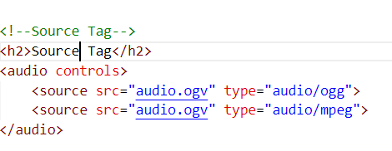

**OUTPUT**

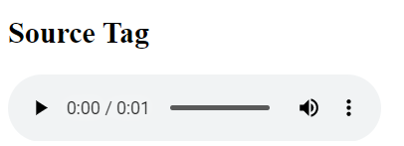

1. **<video>**

The <video> tag is an HTML5 element that is used to embed video content in a web page.

**CODE**

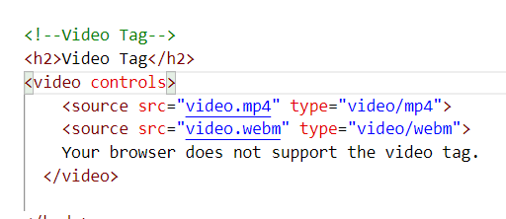

**OUTPUT**

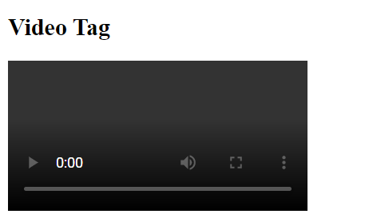

1. **<b>**

The <b> tag specifies bold text without any extra importance.

**CODE**



**OUTPUT**



1. **<base>**

The <base> tag is an HTML element that specifies the base URL and target for all relative URLs in a web page.

**CODE**

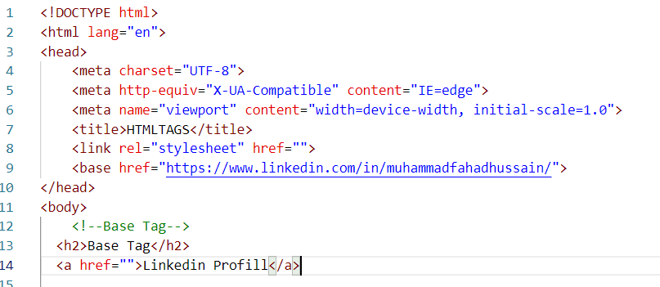

**OUTPUT**

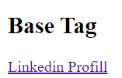

1. **<bdi>**

Represents text that is isolated from its surrounding for the purposes of bidirectional

text formatting.

**CODE**

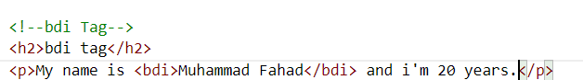

**OUTPUT**

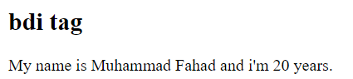

1. **<bdi>**

The <bdo> tag is used to override the current text direction.

**CODE**

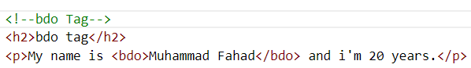

**OUTPUT**

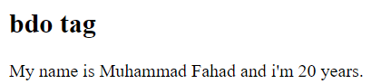

1. **<** **blockquote>**

The <blockquote> tag specifies a section that is quoted from another source.

**CODE**

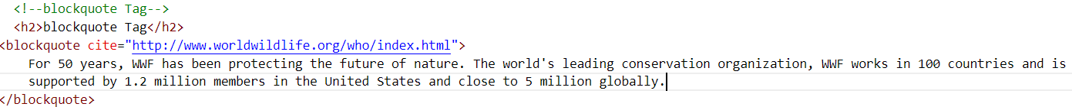

**OUTPUT**



1. **<br>**

The <br> tag inserts a single line break.

**CODE**

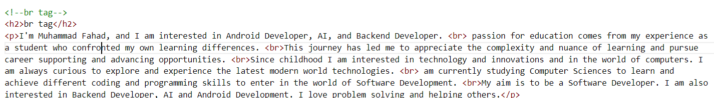

**OUTPUT**



1. **<button>**

The <button> tag is an HTML element that is used to create clickable buttons on a

web page.

**CODE**

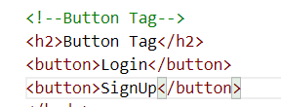

**OUTPUT**

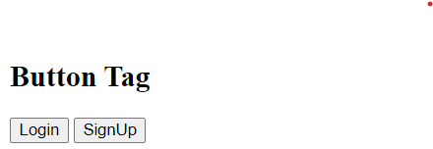

1. **< canvas>**

The <canvas> tag is an HTML element that provides a drawing surface for graphics and animations on a web page.

**CODE**

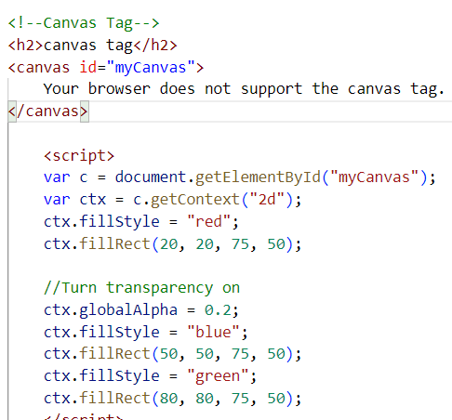

**OUTPUT**

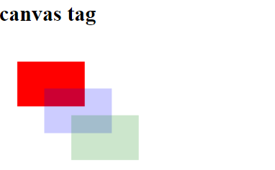

1. **< caption>**

The <caption> tag is an HTML element that is used to add a title or caption to a table. It should be placed immediately after the opening <table> tag and before any <thead>, <tbody>, or <tfoot> tags.

**CODE**

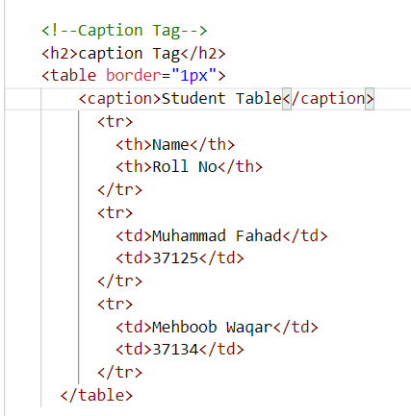

**OUTPUT**

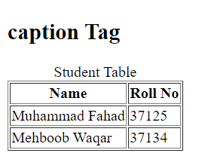

1. **< table>**

The <table> tag is an HTML element used to create a tabular data structure on a web page.

**CODE**

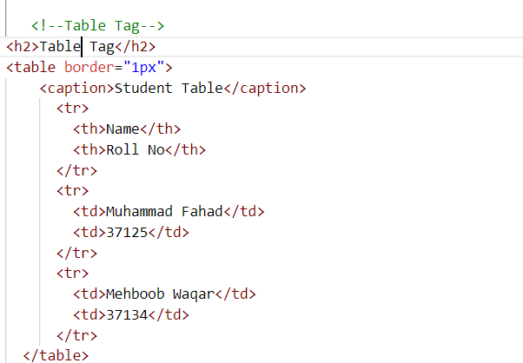

**OUTPUT**

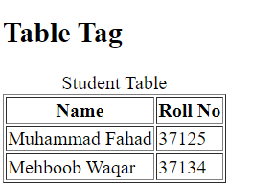

1. **< tr>**

The <tr> tag is an HTML element used to define a row in an HTML table. It is a container element that can contain one or more <td> or <th> elements to define the cells in the row.

**CODE**

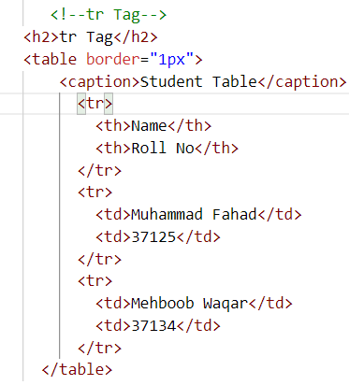

**OUTPUT**

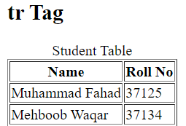

1. **< td>**

The <td> tag is an HTML element used to define a cell in an HTML table. It is used inside a <tr> tag to define the content of a single cell in a table row.

**CODE**

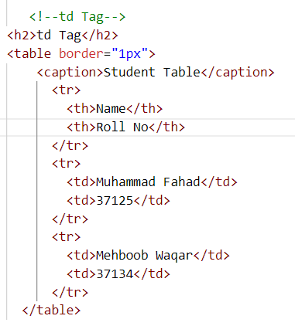

**OUTPUT**

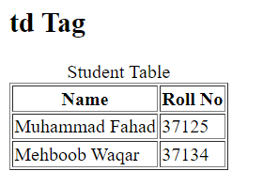

1. **< cite >**

The <cite> tag defines the title of a creative work

**CODE**



**OUTPUT**

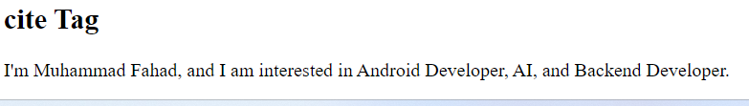

1. **< code>**

He <code> tag is used to define a piece of computer code.

**CODE**

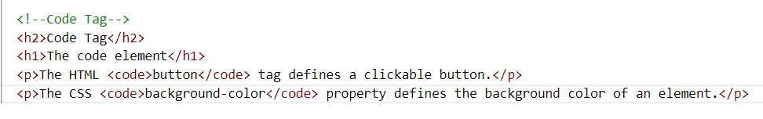

**OUTPUT**

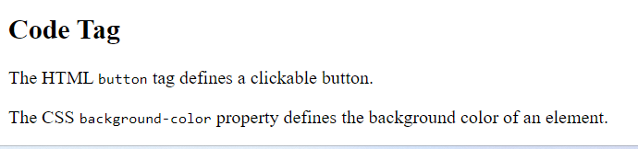

1. **< colgroup >**

The <colgroup> tag specifies a group of one or more columns in a table for formatting.

**CODE**

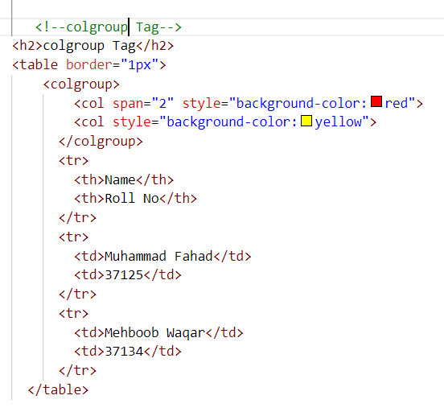

**OUTPUT**

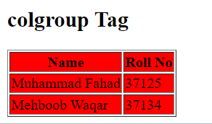

1. **< col >**

The <col> tag is useful for applying styles to entire columns, instead of repeating the styles for each cell, for each row.

**CODE**

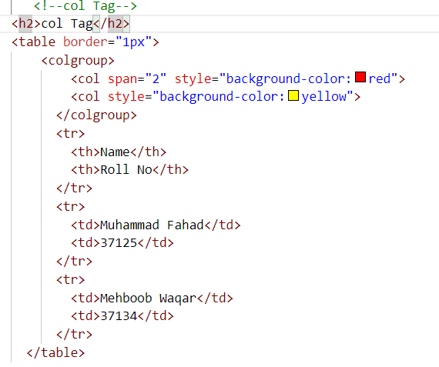

**OUTPUT**

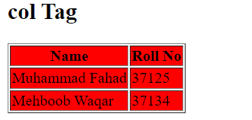

1. **< data >**

The <data> tag is used to add a machine-readable translation of a given content.

**CODE**

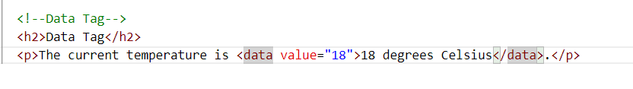

**OUTPUT**

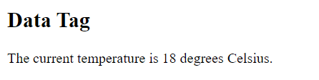

1. **< form >**

The <form> tag is used to create an interactive form that allows users to input data and submit it to a server for processing.

**CODE**

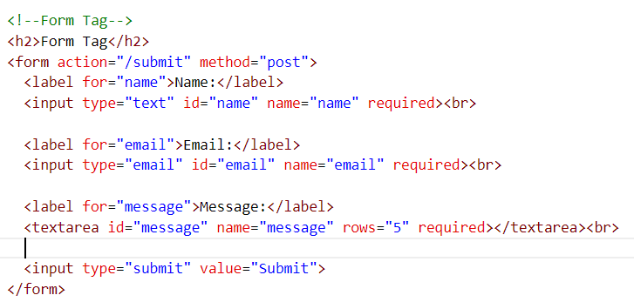

**OUTPUT**

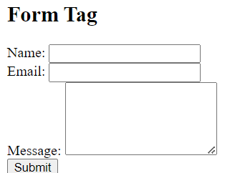

1. **< label >**

The <label> tag is used to associate a label with a form element, such as a text field or checkbox.

**CODE**

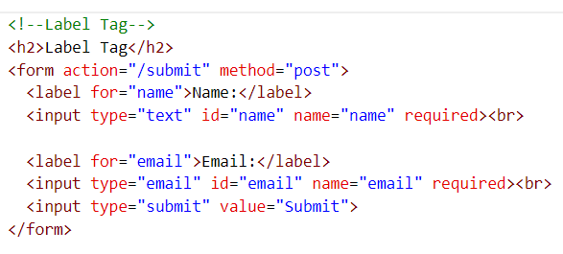

**OUTPUT**

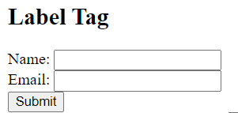

1. **< input >**

The <input> tag is used to create a form element that allows users to input data, such as text, numbers, dates, checkboxes, and radio buttons.

**CODE**

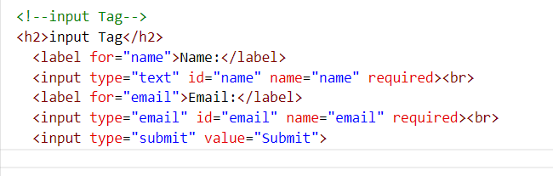

**OUTPUT**

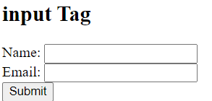

1. **< select >**

The <select> tag is used to create a drop-down list of options that allows users to select one or more items from a list.

**CODE**

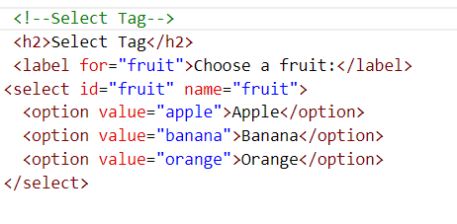

**OUTPUT**

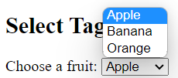

1. **< option >**

The <option> tag is used in conjunction with the <select> tag to create a drop-down list of options for users to choose from

**CODE**

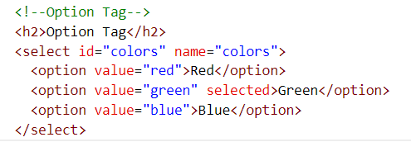

**OUTPUT**

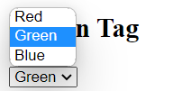

1. **< datalist>**

The <datalist> tag in HTML is used to provide a list of pre-defined options for an input element. It allows users to select one of the pre-defined options or enter their own value.

**CODE**

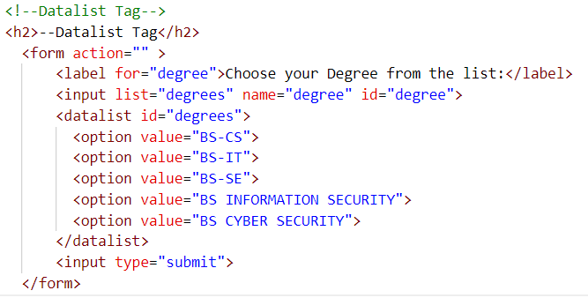

**OUTPUT**

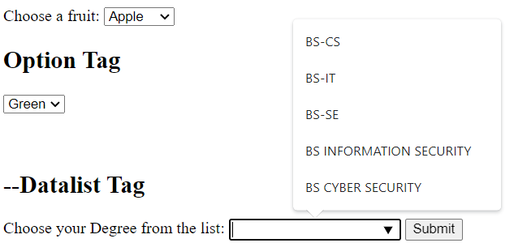

1. **< dd>**

The <dd> tag in HTML is used to define a description in a description list (<dl>). The <dl> element is used to create a list of terms and their descriptions, and each term is defined using the <dt> tag while the corresponding description is defined using the <dd> tag.

**CODE**

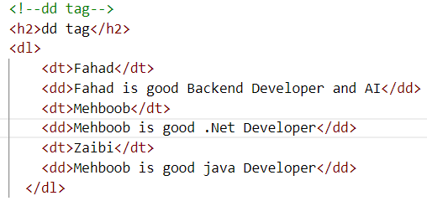

**OUTPUT**

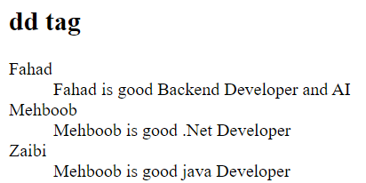

1. **< dl>**

The <dl> tag in HTML is used to create a description list. A description list consists of a series of terms and their corresponding descriptions.

**CODE**

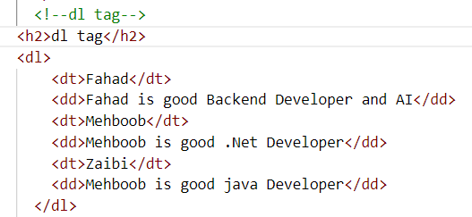

**OUTPUT**

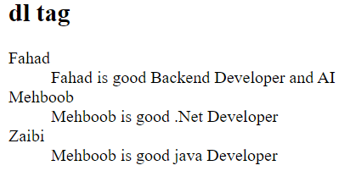

1. **< dt>**

The <dt> tag in HTML is used to define a term in a description list (<dl>). A description list consists of a series of terms and their corresponding descriptions.

**CODE**

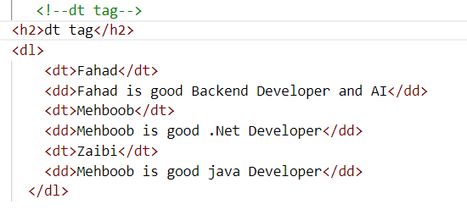

**OUTPUT**

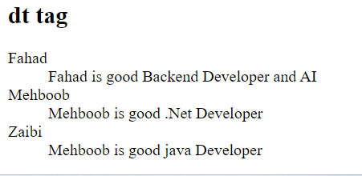

1. **< del>**

The <del> tag in HTML is used to define deleted or removed text from a document. The deleted text is usually displayed with a strikethrough line..

**CODE**

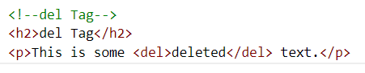

**OUTPUT**

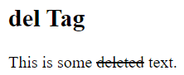

1. **< ins>**

The <ins> tag in HTML is used to define inserted or added text to a document. The inserted text is usually displayed with an underline.

**CODE**

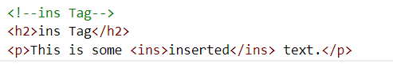

**OUTPUT**

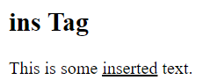

1. **< datail>**

The <details> tag specifies additional details that the user can open and close on demand.

**CODE**



**OUTPUT**

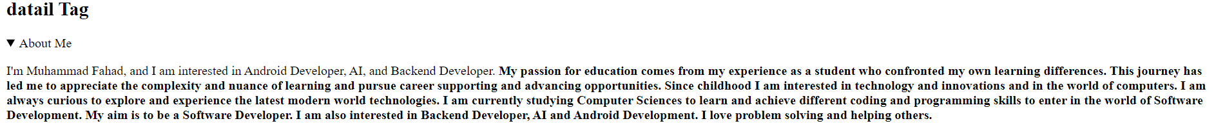

1. **< summary>**

The <summary> tag in HTML is used to define a visible heading for a collapsible element, which can be expanded or collapsed by the user.

**CODE**



**OUTPUT**

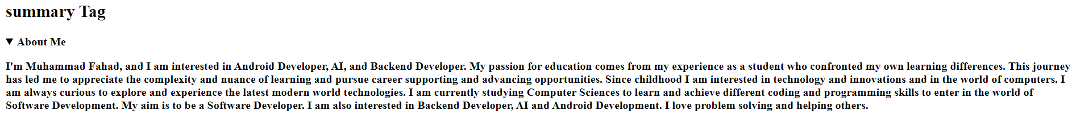

1. **< dfn>**

The <dfn> tag in HTML is used to define a term or phrase in a document.

**CODE**



**OUTPUT**

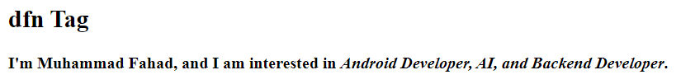

1. **< em>**

The <em> tag in HTML is used to mark up text that should be emphasized or emphasized differently than the surrounding text.

**CODE**

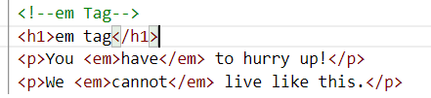

**OUTPUT**

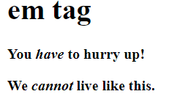

1. **< embed>**

The <embed> tag in HTML is used to embed external content such as audio, video, images, or other interactive media into a web page.

**CODE**

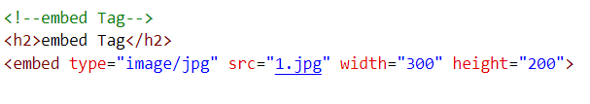

**OUTPUT**



1. **< fieldset >**

The <fieldset> tag draws a box around the related elements.

**CODE**

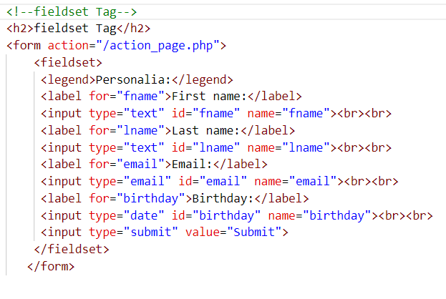

**OUTPUT**

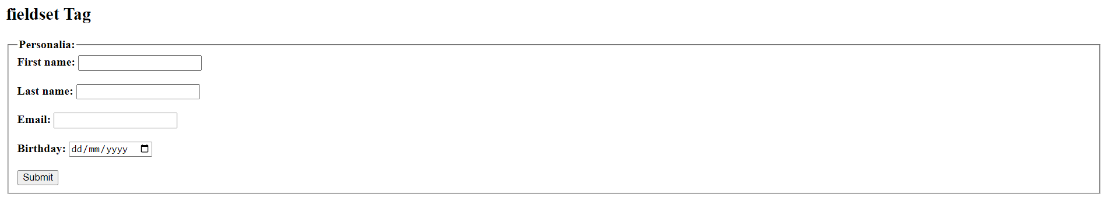

1. **< legend>**

The <legend> tag in HTML is used in combination with the <fieldset> tag to provide a caption or title for a group of related form controls.

**CODE**

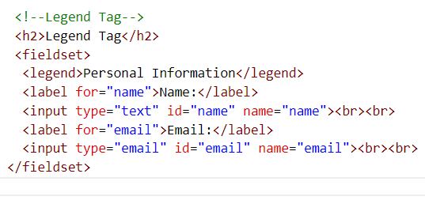

**OUTPUT**

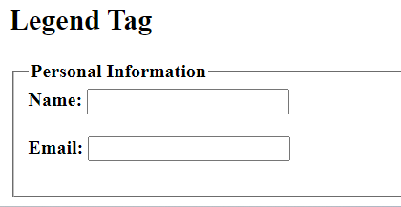

1. **< figure>**

The <figure> tag in HTML is used to mark up self-contained content, such as images, illustrations, diagrams, or code snippets.

**CODE**

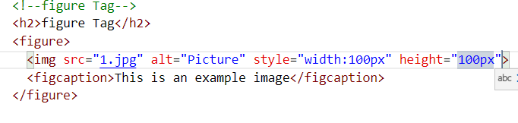

**OUTPUT**

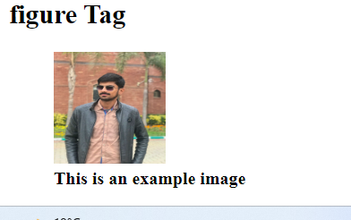

1. **< figcaption >**

The <figcaption> tag is used in HTML in conjunction with the <figure> tag to provide a caption or description for a self-contained content such as images, illustrations, diagrams, or code snippets, that are referred to in the main content of a web page.

**CODE**

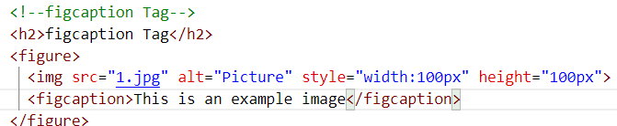

**OUTPUT**

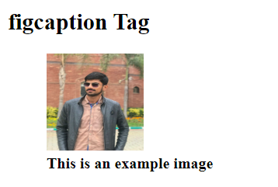

1. **< iframe>**

The <iframe> tag in HTML is used to embed an HTML document or another web page within the current web page.

**CODE**

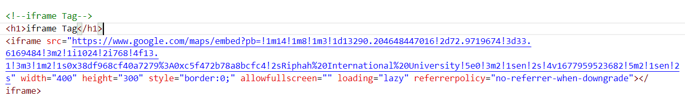

**OUTPUT**

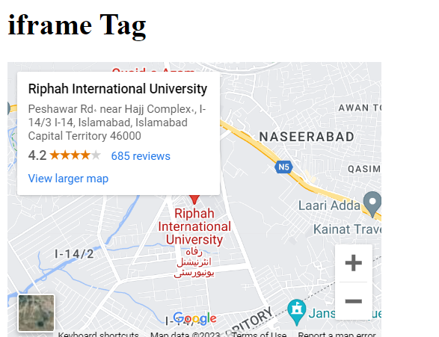

1. **< hr>**

The <hr> element is most often displayed as a horizontal rule that is used to separate content (or define a change) in an HTML page.

**CODE**

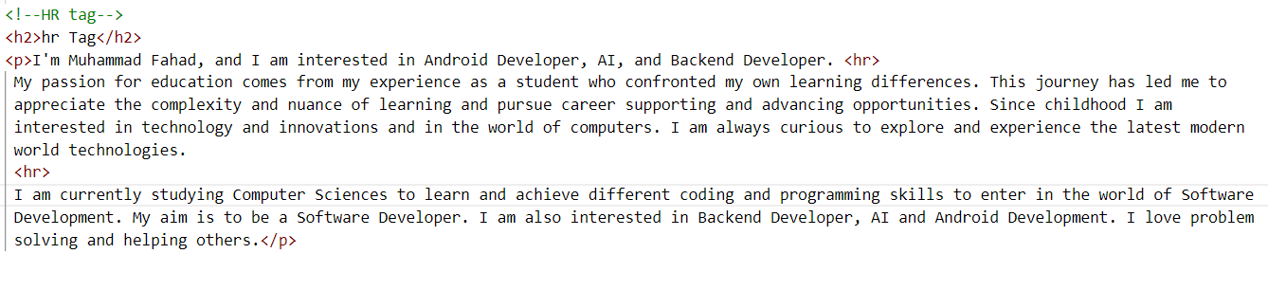

**OUTPUT**



1. **< html>**

The <html> tag is the container for all other HTML elements .

**CODE**

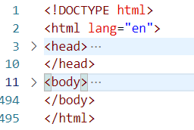

**OUTPUT**

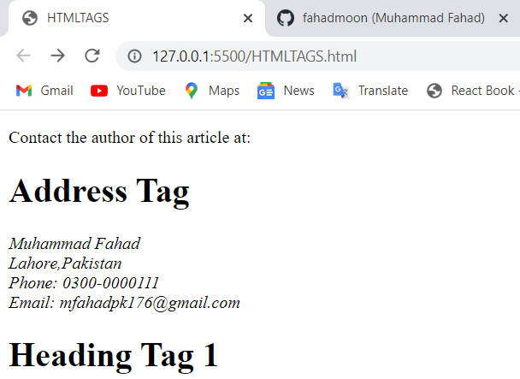

1. **< i>**

The <i> tag defines a part of text in an alternate voice or mood. The content inside is typically displayed in italic.

**CODE**



**OUTPUT**

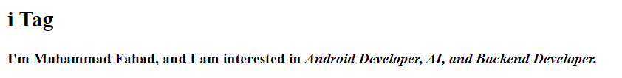

1. **< kbd >**

<kbd> tag is used to define keyboard input. The content inside is displayed in the browser's default monospace font.

**CODE**

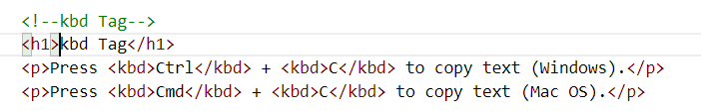

**OUTPUT**

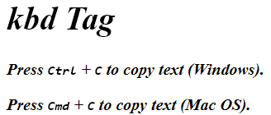

1. **< li>**

The <li> tag defines a list item.

**CODE**

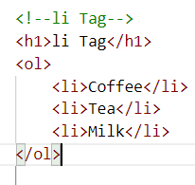

**OUTPUT**

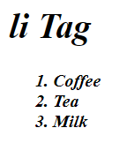

1. **< ol>**

The <ol> tag in HTML is used to define an ordered list, where each list item is numbered in sequence.

**CODE**

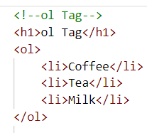

**OUTPUT**

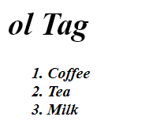

1. **< ul>**

The <ul> tag in HTML is used to define an unordered list, where each list item is marked with a bullet point.

**CODE**

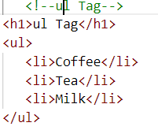

**OUTPUT**

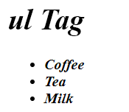

1. **< link>**

The <link> tag defines the relationship between the current document and an external resource.

**CODE**

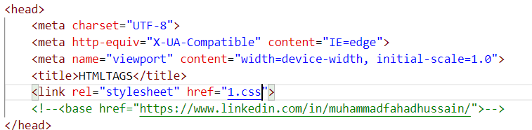



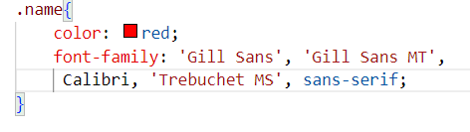

**OUTPUT**

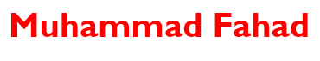

1. **< mark>**

The <mark> tag defines text that should be marked or highlighted.

**CODE**



**OUTPUT**

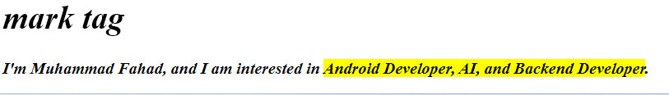

1. **< meta>**

The <meta> tag defines metadata about an HTML document. Metadata is data (information) about data.

**CODE**

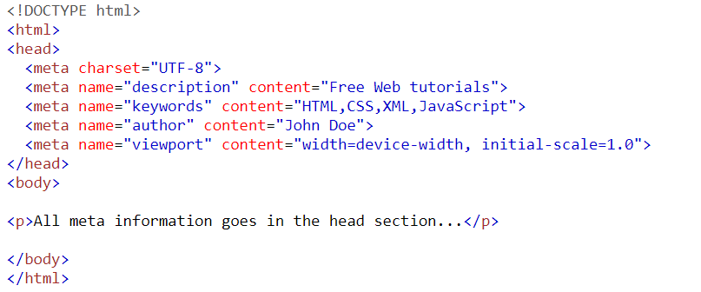

**OUTPUT**



1. **< meter>**

The <meter> tag in HTML is used to define a scalar measurement within a known range, or a fractional value.

**CODE**

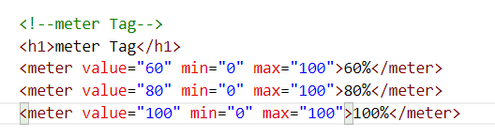

**OUTPUT**

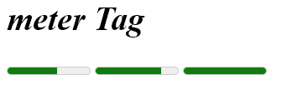

1. **< noscript >**

The <noscript> tag in HTML is used to provide alternative content that should be displayed when the user's browser doesn't support JavaScript, or when JavaScript is disabled in the user's browser.

**CODE**

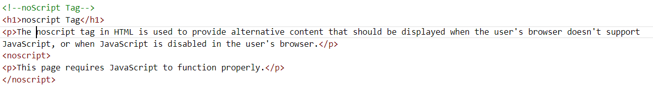

**OUTPUT**



1. **< object>**

The <object> tag defines a container for an external resource.

**CODE**

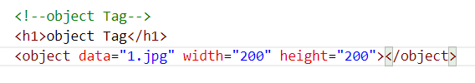

**OUTPUT**



1. **< optgroup>**

The <optgroup> tag is used to group related options in a <select> element.

**CODE**

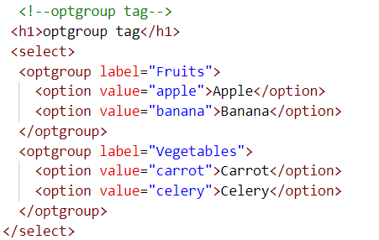

**OUTPUT**

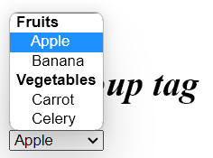

1. **< output>**

The <output> tag in HTML is used to display the result of a calculation or other user input. **CODE**

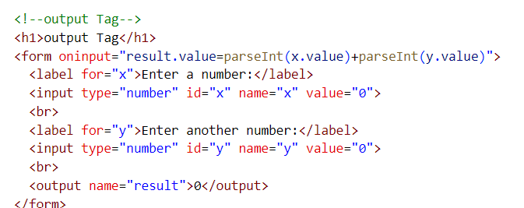

**OUTPUT**

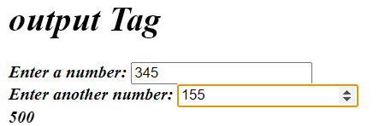

1. **< param>**

The <param> tag in HTML is used to define parameters for an object element, such as a <video> or <audio> element. The <param> tag is nested within the <object> tag, and is used to provide additional information about the object.

**CODE**

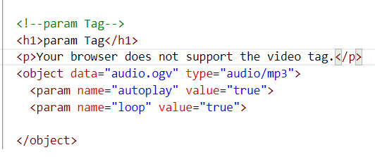

**OUTPUT**

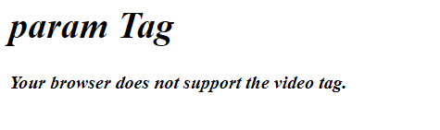

1. **< picture>**

The <picture> tag gives web developers more flexibility in specifying image resources..

**CODE**

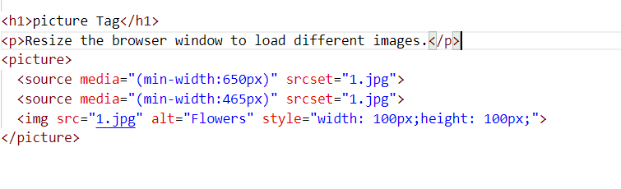

**OUTPUT**

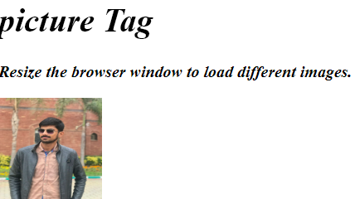

1. **< pre>**

The <pre> tag defines preformatted text.

**CODE**

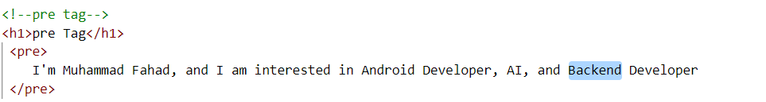

**OUTPUT**

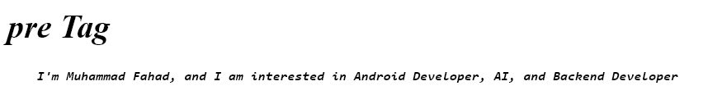

1. **< q>**

The <q> tag defines a short quotation.

**CODE**

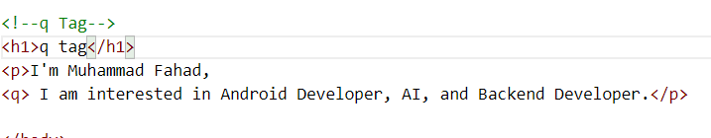

**OUTPUT**

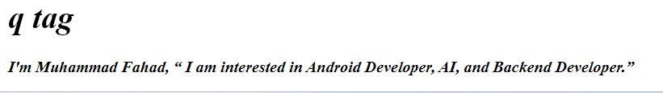

1. **< rp>**

The <rp> tag can be used to provide parentheses around a ruby text, to be shown by browsers that do not support ruby annotations.

**CODE**

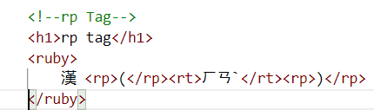

**OUTPUT**

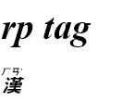

1. **< progress >**

The <progress> tag is an HTML element used to represent the progress of a task, such as the completion percentage of a download, an upload, or a form submission.

**CODE**

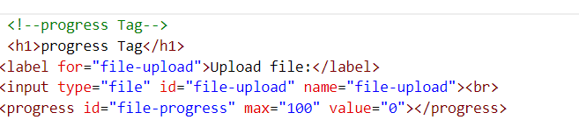

**OUTPUT**

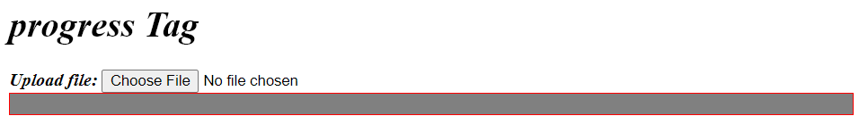

1. **< rt>**

The <rt> tag defines an explanation or pronunciation of characters (for East Asian typography) in a ruby annotation.

**CODE**

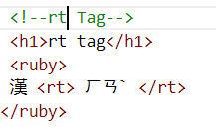

**OUTPUT**

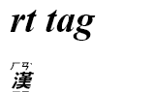

1. **< ruby>**

The <ruby> tag specifies a ruby annotation.

**CODE**

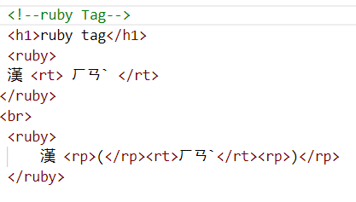

**OUTPUT**

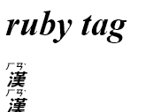

1. **< s>**

The <s> tag is an HTML element used to indicate content that has been deleted or is no longer accurate.

**CODE**

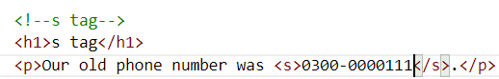

**OUTPUT**

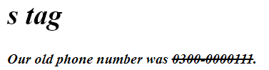

1. **< samp>**

The <samp> tag is an HTML element used to indicate sample output or computer code output.

**CODE**

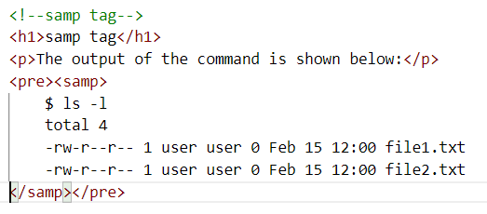

**OUTPUT**

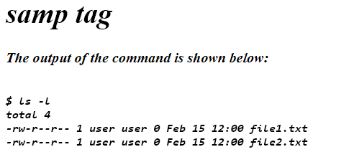

1. **< script >**

The <script> tag is used to embed a client-side script (JavaScript).

**CODE**

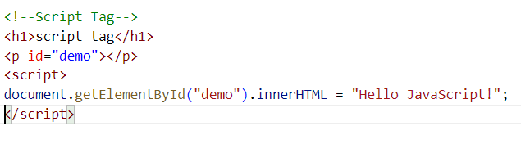

**OUTPUT**

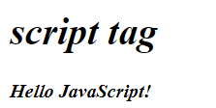

1. **< section>**

The <section> tag is an HTML element that represents a section of a document, such as a chapter, header, footer, or any other distinct grouping of content.

**CODE**

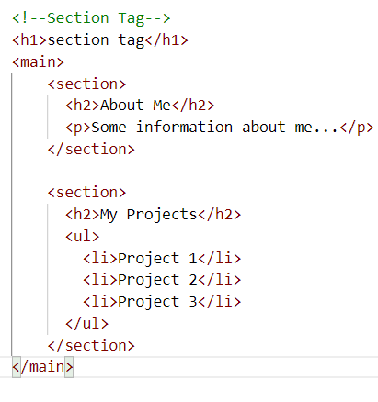

**OUTPUT**

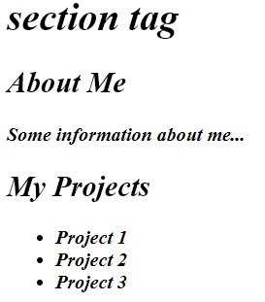

1. **< small>**

The <small> tag defines smaller text.

**CODE**

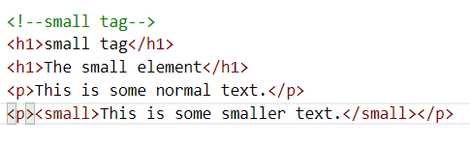

**OUTPUT**

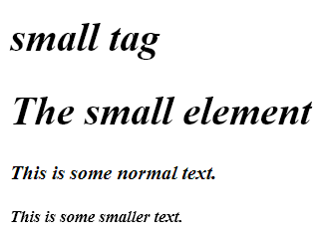

1. **< span>**

The <span> tag is an inline container used to mark up a part of a text, or a part of a document.

**CODE**

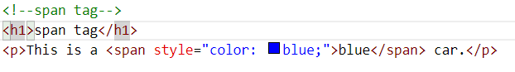

**OUTPUT**

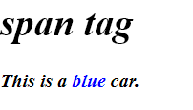

1. **< strong>**

The strong tag is used to indicate that the text within it has strong importance, importance that is stronger than its surrounding text.

**CODE**



**OUTPUT**

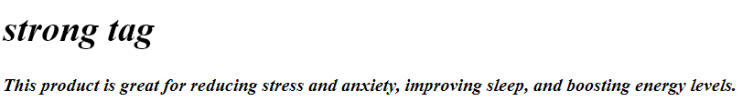

1. **< style>**

The <style> tag is used to define style information (CSS) for a document.

**CODE**

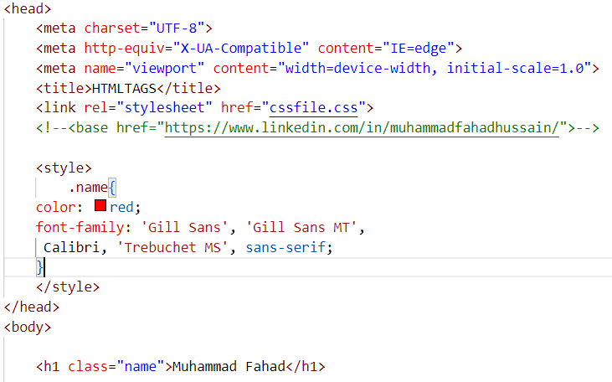

**OUTPUT**

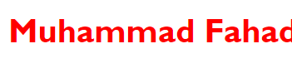

1. **< sub>**

The <sub> tag defines subscript text. Subscript text appears half a character below the normal line, and is sometimes rendered in a smaller font. Subscript text can be used for chemical formulas, like H2O.

**CODE**

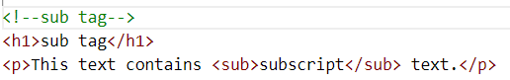

**OUTPUT**

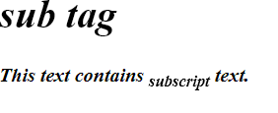

1. **< sup>**

The <sup> tag defines superscript text. Superscript text appears half a character above the normal line, and is sometimes rendered in a smaller font.

**CODE**

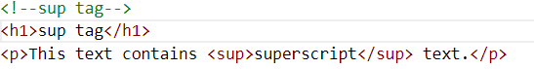

**OUTPUT**

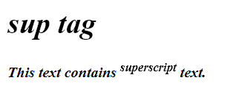

1. **< svg>**

The <svg> tag defines a container for SVG graphics.

**CODE**

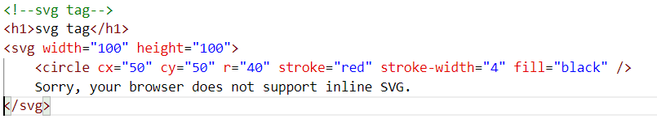

**OUTPUT**

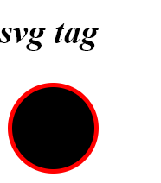

1. **< circle>**

The circle is not an HTML tag. However, it is a graphical shape that can be created using SVG (Scalable Vector Graphics) and displayed on an HTML page using an SVG circle element.

**CODE**

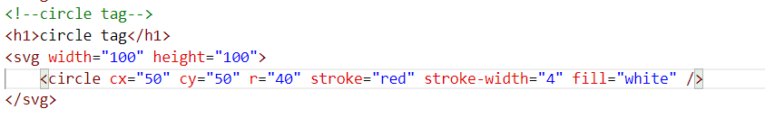

**OUTPUT**

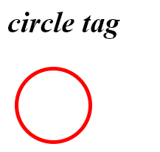

1. **< tbody>**

The <tbody> tag is used to group the body content in an HTML table.

**CODE**

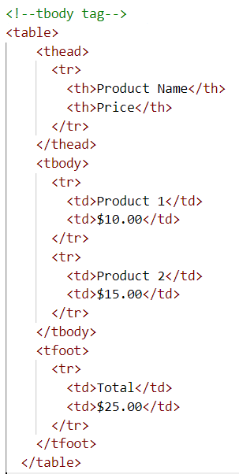

**OUTPUT**

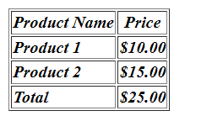

1. **< thead>**

The <thead> tag is used in HTML to group the header content in a table. It is used as a container for one or more <tr> (table row) elements that define the header cells of the table.

**CODE**

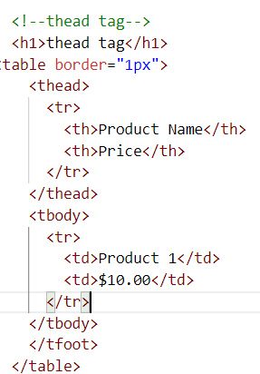

**OUTPUT**

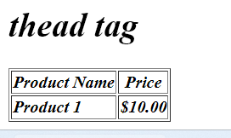

1. **< tfoot>**

he <tfoot> tag is used to group footer content in a table. It is used in conjunction with the <table> and <tr> tags to define the footer section of the table.

**CODE**

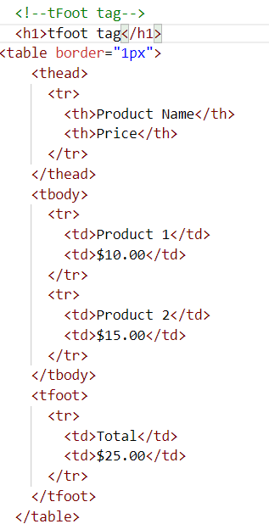

**OUTPUT**

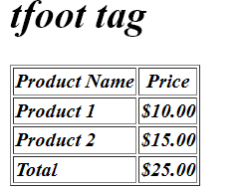

1. **< template>**

The <template> tag is an HTML5 element used to declare HTML fragments that can be cloned and inserted into a document by JavaScript. The content inside a <template> tag is not rendered when the page loads but can be accessed and used by JavaScript.

**CODE**

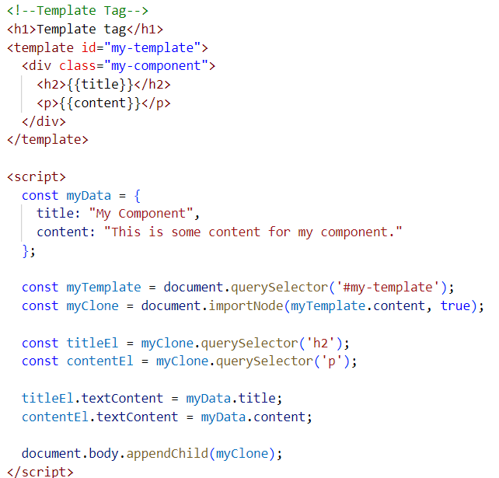

**OUTPUT**

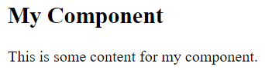

1. **< tfoot>**

he <tfoot> tag is used to group footer content in a table. It is used in conjunction with the <table> and <tr> tags to define the footer section of the table.

**CODE**

**OUTPUT**

1. **< tfoot>**

he <tfoot> tag is used to group footer content in a table. It is used in conjunction with the <table> and <tr> tags to define the footer section of the table.

**CODE**

**OUTPUT**